Andrew Smith

Career Foundry Data Immersion

January 16, 2022

3.6: Summarizing & Cleaning Data in SQL (Answers 3.6)

1)

**a)**There were no duplicates found in either table but, if there were any, I would start the duplicate removal process by creating a virtual table or “view” with the same columns used in the commands below. Then I would create a duplicate deleting command with that keeps the lowest unique ID value, so the table only keeps one version of the duplicate.

**a)Duplicate command: Film table**

SELECT title,

release_year,

language_id,

rental_duration,

COUNT(*)

FROM film

GROUP BY title,

release_year,

language_id,

rental_duration

HAVING COUNT(*) >1;

**a)Duplicate command: Customer table**

SELECT customer_id,

store_id,

first_name,

last_name,

email,

COUNT(*)

FROM customer

GROUP BY customer_id,

store_id,

first_name,

last_name,

email

HAVING COUNT(*) >1;

**b)**Nonuniform/Incorrect data Commands

Every column appears to be uniform in both tables, but if anything was not uniform, then I would use the GROUP BY command for each category to find which piece of data is different from the rest. Then I would use an UPDATE function to change the nonuniform data to match the corresponding value.

**b)**Example GROUP BY command:

SELECT rating

FROM film

GROUP BY rating

**b)**Example UPDATE command that has nonuniform values:

UPDATE film

SET rating = 'G'

WHERE rating IN ('gen',

'g',

'General')

**c)**Missing Values Commands

There appears to be no missing data in either table, but if there was then I would have two options depending on the scenario. I could simply ignore a column that contained missing data when conducting a typical SELECT command and adding a note explaining why a column is left out. The other option would be to impute the null values with an estimate. I could do this by creating an UPDATE command where the average of a column is used to fill in the missing values.

**c)**Example SELECT command that is ignoring a column with missing values

SELECT film_id,

title,

length... –rental_duration ignored in select because it has a lot of missing values

FROM film

**c)**Example UPDATE command to fill in the missing values with the column averages

UPDATE film

SET = AVG(rental_duration)

WHERE rental_duration IS NULL

2)

**Numerical Descriptive Statistic Queries (Customer table)**

(MIN, MAX, AVG) Customer_id, store_id,address_id,active

SELECT MIN(customer_id) AS min_customer_id,

MAX(customer_id) AS max_customer_id,

AVG(customer_id) AS avg_customer_id,

min(store_id) AS min_store_id,

max(store_id) AS max_store_id,

avg(store_id) AS avg_store_id,

min(address_id) AS min_address_id,

max(address_id) AS max_address_id,

avg(address_id) AS avg_address_id,

min(active) AS min_active,

max(active) AS max_active,

avg(active) AS avg_active

FROM customer;

EXTRA?

(MIN, MAX) Create_date, last_update

SELECT min(create_date) AS min_create_date,

max(create_date) AS max_create_date,

min(last_update) AS min_last_update,

max(last_update) AS max_last_update

FROM customer;

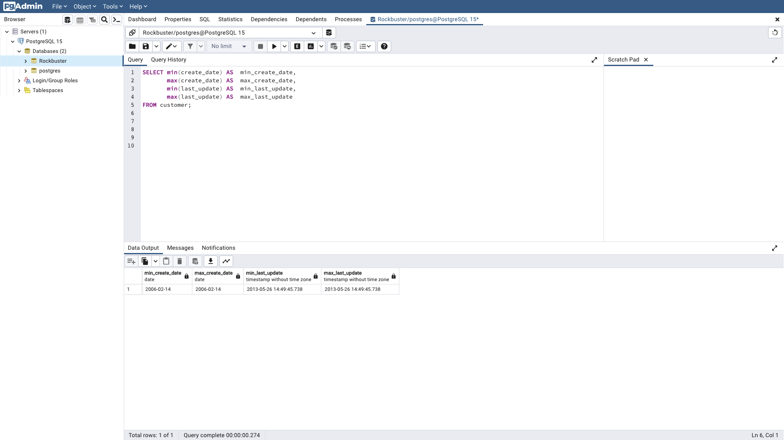

*avg command did not work for the create_date & last_update columns

**Non-Numerical Descriptive Statistic Queries (Customer table)**

First_name COUNT

SELECT first_name,

COUNT(*)

FROM customer

GROUP BY first_name

ORDER BY COUNT DESC

First_name MODE

SELECT mode() WITHIN GROUP (ORDER BY first_name)

AS modal_value

FROM customer;

Last_name COUNT

SELECT last_name,

COUNT(*)

FROM customer

GROUP BY last_name

ORDER BY COUNT DESC

Last_name MODE

SELECT mode() WITHIN GROUP (ORDER BY last_name)

AS modal_value

FROM customer;

Email COUNT

SELECT email,

COUNT(*)

FROM customer

GROUP BY email

ORDER BY COUNT DESC

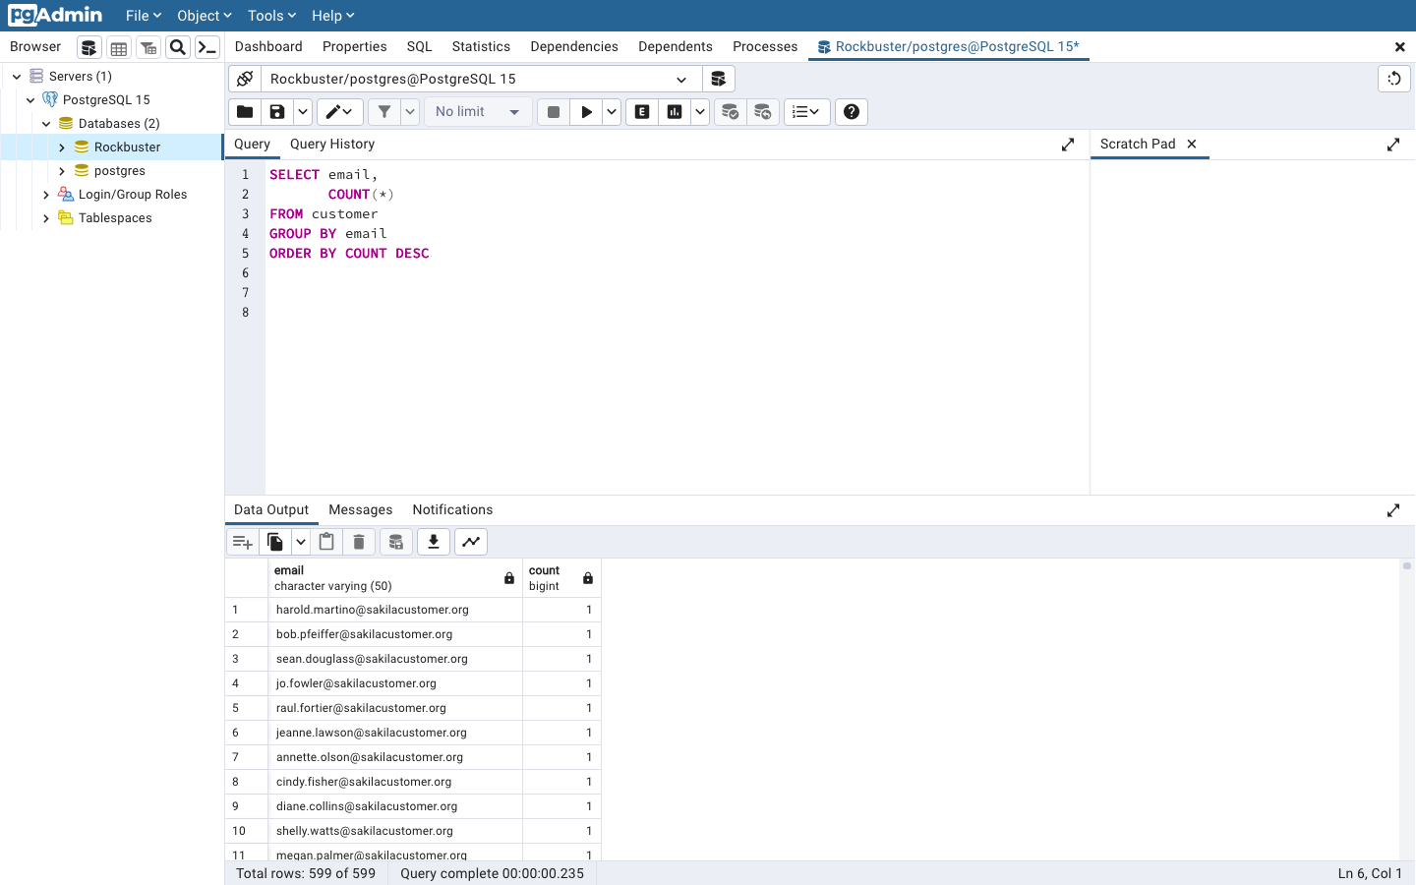

Email MODE

SELECT mode() WITHIN GROUP (ORDER BY email)

AS modal_value

FROM customer;

Activebool COUNT

SELECT activebool,

COUNT(*)

FROM customer

GROUP BY activebool

ORDER BY COUNT DESC

Activebool MODE

SELECT mode() WITHIN GROUP (ORDER BY activebool)

AS modal_value

FROM customer;

EXTRA?

Create_date COUNT

SELECT create_date,

COUNT(*)

FROM customer

GROUP BY create_date

ORDER BY COUNT DESC

Create_date MODE

SELECT mode() WITHIN GROUP (ORDER BY create_date)

AS modal_value

FROM customer;

Last_update COUNT

SELECT last_update,

COUNT(*)

FROM customer

GROUP BY last_update

ORDER BY COUNT DESC

Last_update MODE

SELECT mode() WITHIN GROUP (ORDER BY last_update)

AS modal_value

FROM customer;

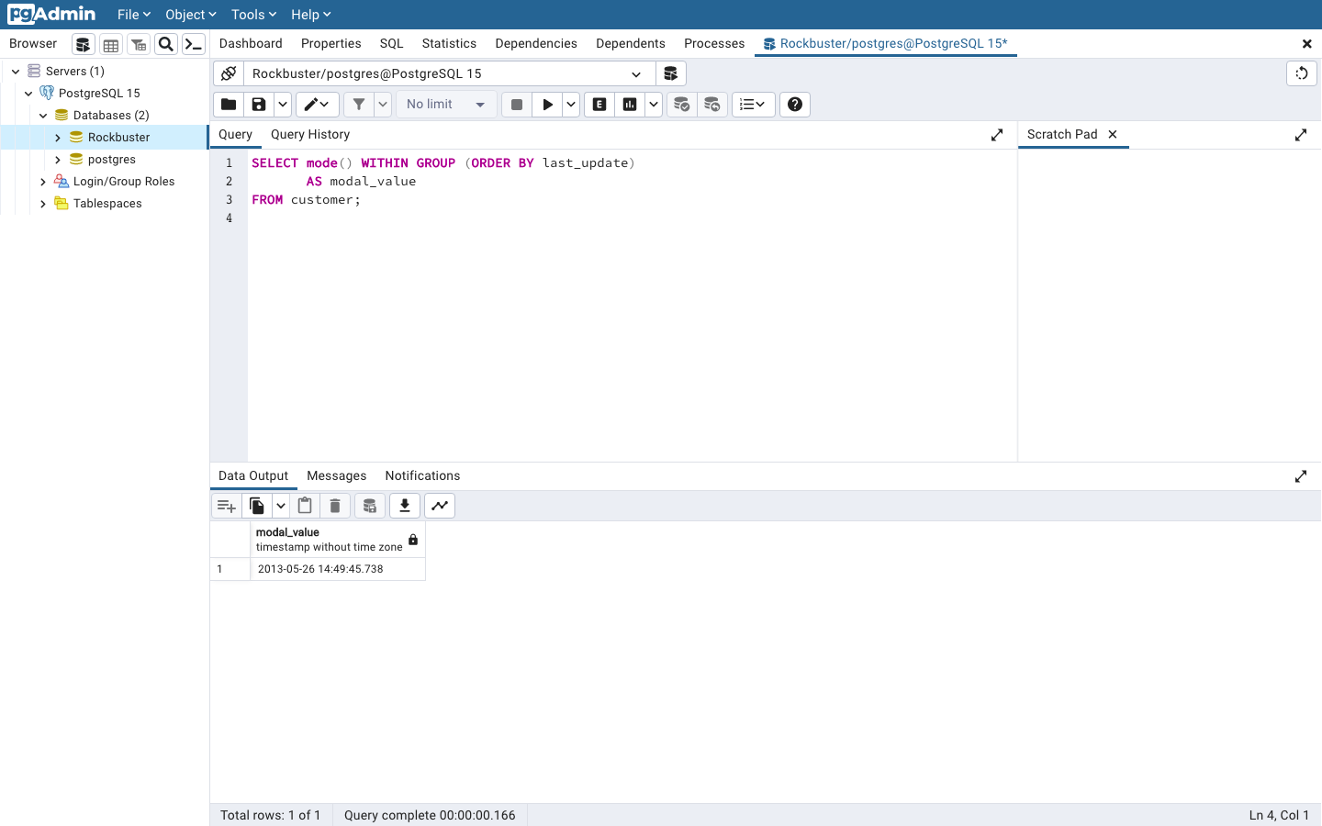

**\*\*\*\*Numerical Descriptive Statistic Queries (Film table)**

(MIN, MAX, AVG) film_id, release_year, language_id, rental_duration, rental_rate, length, replacement cost

SELECT MIN(film_id) AS min_film_id,

MAX(film_id) AS max_film_id,

AVG(film_id) AS avg_film_id,

MIN(release_year) AS min_release_year,

MAX(release_year) AS max_release_year,

AVG(release_year) AS avg_release_year,

MIN(language_id) AS min_language_id,

MAX(language_id) AS max_language_id,

AVG(language_id) AS avg_language_id,

MIN(rental_duration) AS min_rental_duration,

MAX(rental_duration) AS max_rental_duration,

AVG(rental_duration) AS avg_rental_duration,

MIN(rental_rate) AS min_rental_rate,

MAX(rental_rate) AS max_rental_rate,

AVG(rental_rate) AS avg_rental_rate,

MIN(length) AS min_length,

MAX(length) AS max_length,

AVG(length) AS avg_length,

MIN(replacement_cost) AS min_replacement_cost,

MAX(replacement_cost) AS max_replacement_cost,

AVG(replacement_cost) AS avg_replacement_cost

FROM film;

-There are three screenshots since I had to scroll through the query/query output to show all results.

EXTRA?

(MIN, MAX) last_update

SELECT min(last_update) AS min_last_update,

max(last_update) AS max_last_update

FROM film;

*avg command did not work for the last_update column

**Non-Numerical Descriptive Statistic Queries (Film table)**

(COUNT & MODE) Title, rating, description, special_features, fulltext

Title COUNT

SELECT title,

COUNT(*)

FROM film

GROUP BY title

ORDER BY COUNT DESC

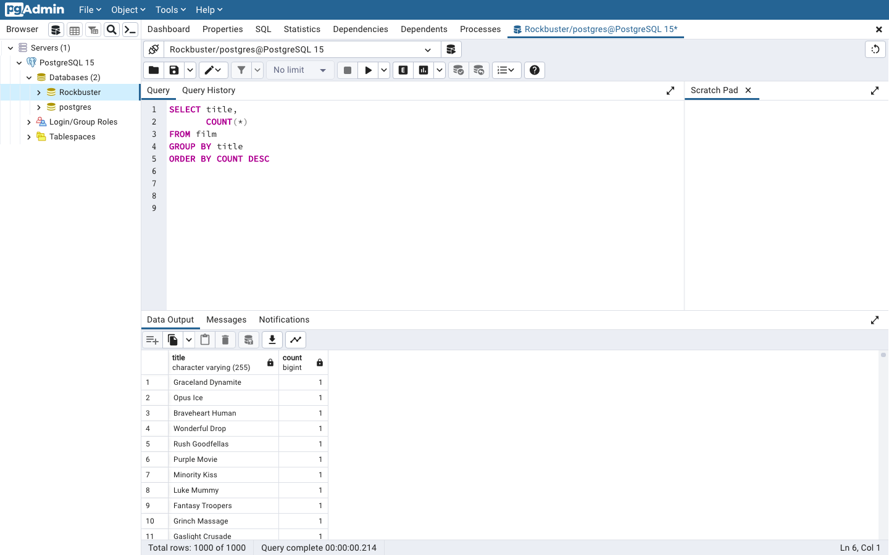

Title MODE

SELECT mode() WITHIN GROUP (ORDER BY title)

AS modal_value

FROM film;

Rating COUNT

SELECT rating,

COUNT(*)

FROM film

GROUP BY rating

ORDER BY COUNT DESC

Rating MODE

SELECT mode() WITHIN GROUP (ORDER BY rating)

AS modal_value

FROM film;

Description COUNT

SELECT description,

COUNT(*)

FROM film

GROUP BY description

ORDER BY COUNT DESC

Description MODE

SELECT mode() WITHIN GROUP (ORDER BY description)

AS modal_value

FROM film;

Special_features COUNT

SELECT special_features,

COUNT(*)

FROM film

GROUP BY special_features

ORDER BY COUNT DESC

Special_features MODE

SELECT mode() WITHIN GROUP (ORDER BY special_features)

AS modal_value

FROM film;

Fulltext COUNT

SELECT fulltext,

COUNT(*)

FROM film

GROUP BY fulltext

ORDER BY COUNT DESC

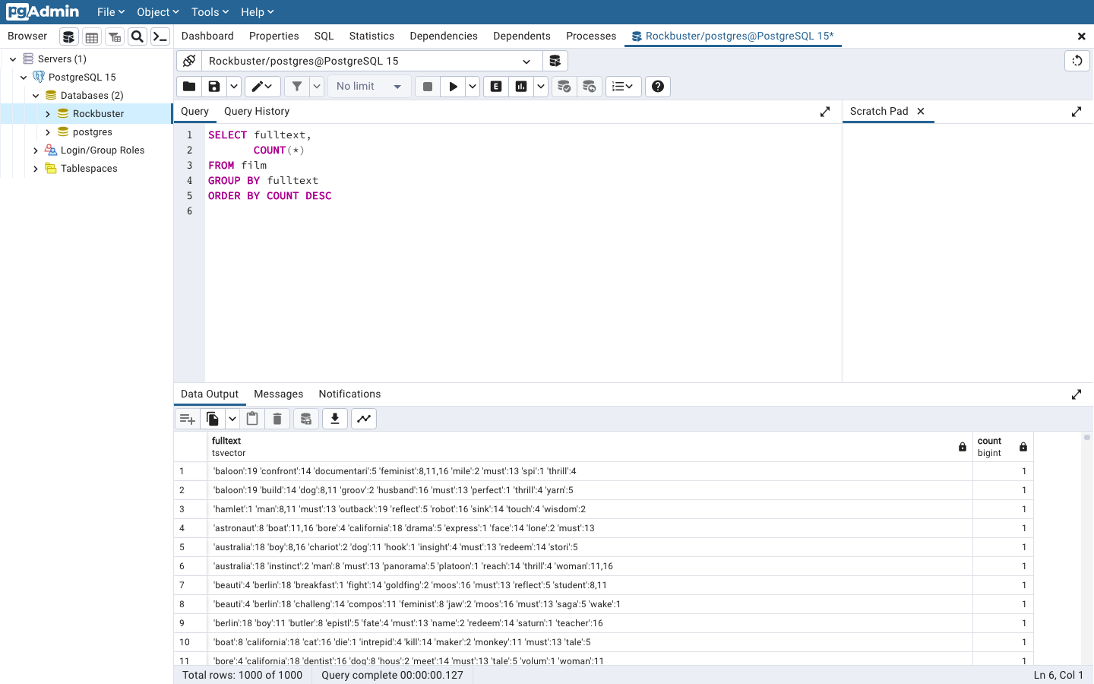

Fulltext MODE

SELECT mode() WITHIN GROUP (ORDER BY fulltext)

AS modal_value

FROM film;

EXTRA?

Last_update COUNT

SELECT last_update,

COUNT(*)

FROM film

GROUP BY last_update

ORDER BY COUNT DESC

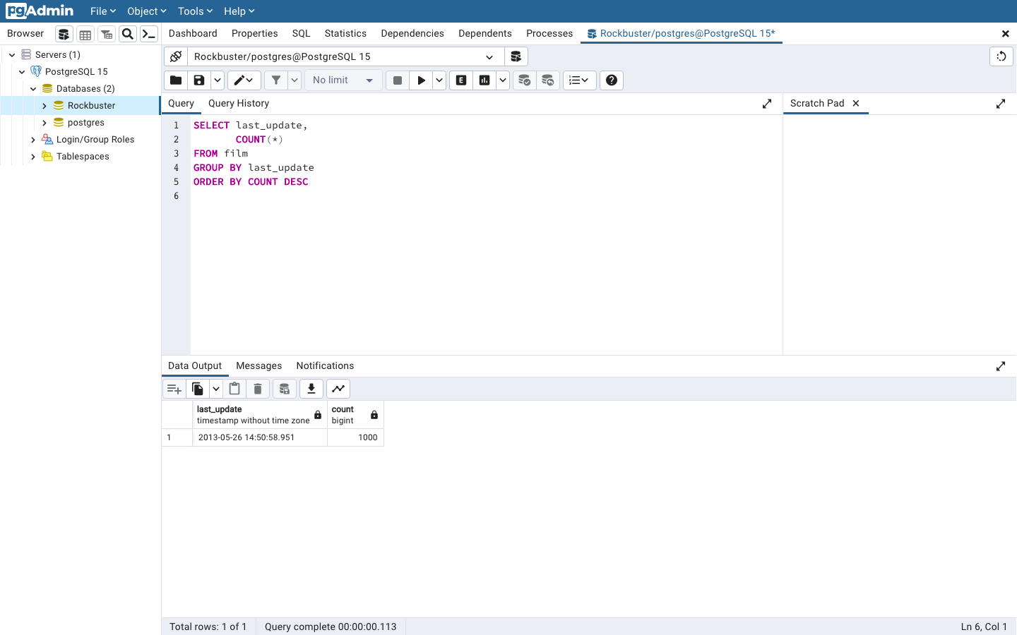

Last_update MODE

SELECT mode() WITHIN GROUP (ORDER BY last_update)

AS modal_value

FROM film;

3)

I think SQL is much more effective for data profiling compared to Excel for a few different reasons. I find it is easier and faster to type a command in SQL to calculate descriptive statistics rather than having to highlight columns/rows in Excel and then typing a formula. SQL is especially helpful for performing multiple descriptive statistics at once rather than inputting each formula at a time in Excel.